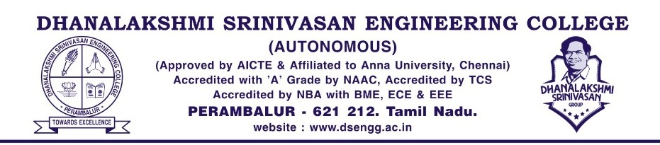

27/7/23

**Report on FDP – An Overview about AI Enabled Learning through CHATGPT**

Greeting from Dhanalakshmi Srinivasan Engineering College. We have conducted Faculty Development on An Overview about AI Enabled Learning through CHATGPT on 27th August 10, 2023 (10.30 am to 4.30 pm) started with welcome address by Dr M Sridevi Vice Principal/DSEC followed by introduction of Chief guest by Ms R Amitha Varshini AP/BioTech. Our beloved Principal Dr K Elangovan gave felicitation address and honored our chief guest by handed over gift as token of our love. Our Chief guest Mr RV Saravana Prakash Chairman, VIBA EdTech as gave chief guest address as well as handled hands on training on AI Enabled Learning through CHATGPT. Around 75 faculties were attended. This programs was more interactive one especially this is eye opening for most of them as how to use CHATGPT in education. Finally Dr Katherasan Duraisamy,( FDP - Co-ordinator) HoD /RAA gave vote of thanks.

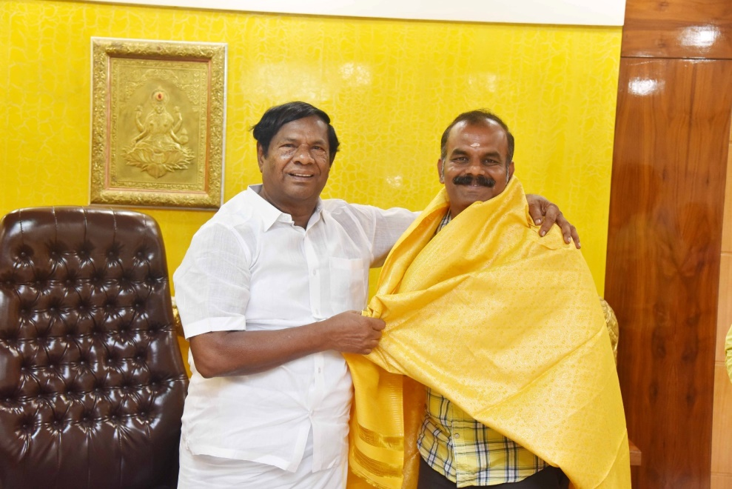

|  |  |
| --- | --- |
| C:\Users\RAA\Downloads\WhatsApp Image 2023-08-10 at 16.13.10.jpeg | C:\Users\RAA\Downloads\WhatsApp Image 2023-08-10 at 16.12.33.jpeg |
| C:\Users\RAA\Downloads\WhatsApp Image 2023-08-10 at 16.12.35.jpeg | C:\Users\RAA\Downloads\WhatsApp Image 2023-08-10 at 16.12.34.jpeg |
| C:\Users\RAA\Downloads\WhatsApp Image 2023-08-10 at 16.12.36.jpeg | C:\Users\RAA\Downloads\WhatsApp Image 2023-08-10 at 16.13.09.jpeg |
| C:\Users\RAA\Downloads\WhatsApp Image 2023-08-10 at 16.12.37.jpeg | C:\Users\RAA\Downloads\WhatsApp Image 2023-08-10 at 16.13.09 (1).jpeg |

